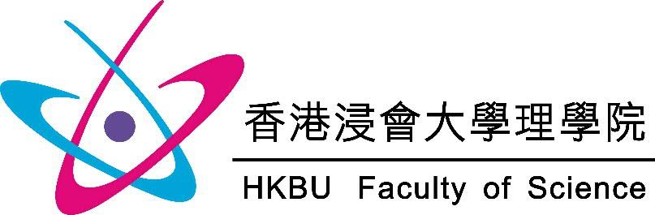
Registration Deadline
10 May 2024 (Friday)

Science Festival 2024

Registration Form

To: Faculty of Science, Hong Kong Baptist University (Attn.: Miss Lam)
Enquiry: 3411 2378 E-mail: sci@hkbu.edu.hk

- School Information*
Name of School: (CHI)
(ENG)
Contact Person: ______________________________________ | Contact No. : ___________________________________
E-mail: _______________________________________________________________________________________________

- Number of Participants
Form | F.1 | F.2 | F.3 | F.4 | F.5 | F.6 | Total
Students

Total Number of Teachers:

- Preferences of Activities
Please indicate your preferences for the activities (on a scale of “1-5”, with “1” being your first preference), timeslot(s) and the number of participants. Activities with limited quotas will be assigned on a first-come, first-served basis.

Preferred Timeslot | Activities | Quota Per Session | Preference | No. of participants
Booth
10:00 – 12:00  13:00 – 16:00 | Food Waste Ring Toss  減少廚餘套圈圈 | Walk-ins Welcome
Low-carbon Living Jenga Tower
低碳生活層層疊
Eliminate the Resource-wasting Monsters
消滅浪費資源小魔怪
Workshop
11:30 – 12:30 | Biochar Magic: Unlocking Wastewater Solutions  生物炭魔法﹕解鎖廢水處理新方法 | 30
11:30 – 12:30 | Minimizing Food Waste through Food Analysis  食物分析減廚餘 | 25
10:15 – 11:15  14:00 – 15:00 | Building a Waste Collection Chabot  打造廢物收集聊天機械人小幫手 | 60
11:30 – 12:30 | Become a Waste Bag Saving Expert  成為垃圾袋節約達人 | 25
10:00 – 11:00  11:15 – 12:15  12:30 – 13:30  14:30 – 15:30 | Natural Mosquito Repellent Sachet Making Workshop  天然驅蚊包工作坊 | 30
10:00 – 11:00  11:15 – 12:15  12:30 – 13:30  14:30 – 15:30 | Handmade Soap Making Workshop  手工皂製作工作坊 | 30
Scientific Demonstration / Guided Tour
10:00 – 16:00 | Waste to Resource: Turn Municipal Organic Waste into Biofuel and Biopolymers  轉廢為能﹕將都市有機廢物轉為生物燃料和生物聚合物 | Walk-ins Welcome  (10 – 15 per group)
10:00 – 11:00  11:30 – 12:30 | Chemistry Laboratory Tour  參觀化學實驗室 | 25
10:00 – 11:00  11:30 – 12:30 | Plastics Come Alive  塑膠重生 | 25
10:00 – 10:30  11:00 – 11:30  12:00 – 12:30  14:00 – 14:30 | IoT in Smart Waste Management  IoT 智能廢物管理 | 20
10:30 – 12:30  14:00 – 16:00 | BSc in Computer Science Graduation Exhibition  計算機科學系本科畢業作品展 | Walk-ins Welcome
10:00 – 16:00 | Exhibition of Waste-Free Science Video Entries  「零廢科學」參賽短片展覽

- Arrival and Departure Time

Please provide the earliest arrival and latest departure times of your school for the Faculty’s better arrangement.
Earliest Arrival Time (e.g. 10:00): | Latest Departure Time (e.g. 16:00):

Important Note

Hong Kong Baptist University (the “University”) is committed to ensuring that your personal data is handled in accordance with the law and the University’s Privacy Policy Statement and Personal Information Collection Statement (“PPS & PICS”) (https://bupdpo.hkbu.edu.hk/policies-and-procedures/pps-pics/). It is mandatory for you to provide the personal data marked with asterisks (*). In the absence of such data, we will not be able to process your registration.

By submitting this form, you acknowledge that you have been provided with the PPS & PICS and have read and accepted the contents thereof. For access to and correction of personal data submitted, please email to sci@hkbu.edu.hk.

